1.He is **on** a special diet

2. They are coming **from** college.

3. We are capable **of** doing difficult tasks.

4. The organisers didn't allow us **on** the stage **to** perform.

5. She is going **to** college.

6. I am **with** my friend now.

7. The pen is **inside** the box.

8. It was solved **by** them.

9. I am working **under** his guidance.

10. We are waiting **for** them.

11. The meeting is **at** 6pm.

12. They are waiting **in** the lobby **for** us.

13. He is **on** the bus now.

14. We are celebrating Holi **in** a grand manner.

15. He sold his computer **to** his friend **for** 10k.

1. He is efficient in his work.

2. They are responsible in discharging their duties.

3. He is an honest man.

4. The natural resources are abundant in India.

5. We all are curious to learn new things.

1.The company reported an increase in profits for the third quarter, exceeding expectations from analysts across the industry.

1.While neither of them knew whether to go work or not, they decided to stay indoors and watch a movie, since it was raining outside.

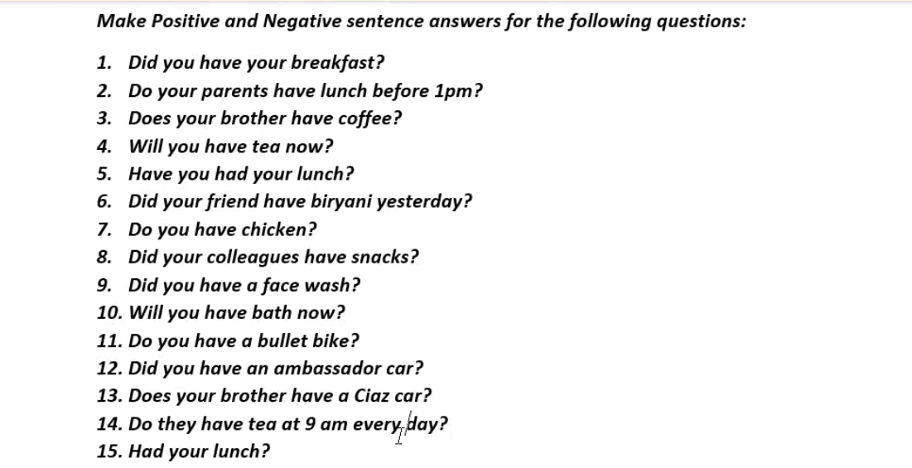

============================================================

1. Positive: Yes, I had my breakfast.

Negative: No, I did not have my breakfast.

2. Positive: Yes, my parents have lunch before 1 pm.

Negative: No, my parents do not have lunch before 1 pm.

3. Positive: Yes, my brother has coffee.

Negative: No, my brother does not have coffee.

4. Positive: Yes, I will have tea now.

Negative: No, I will not have tea now.

5. Positive: Yes, I have had my lunch.

Negative: No, I have not had my lunch.

6. Positive: Yes, my friend had biryani yesterday.

Negative: No, my friend did not have biryani yesterday.

7. Positive: Yes, I have chicken.

Negative: No, I do not have chicken.

8. Positive: Yes, my colleagues had snacks.

Negative: No, my colleagues did not have snacks.

9. Positive: Yes, I had a face wash.

Negative: No, I did not have a face wash.

10. Positive: Yes, I will have a bath now.

Negative: No, I will not have a bath now.

11. Positive: Yes, I have a bullet bike.

Negative: No, I do not have a bullet bike.

12. Positive: Yes, I had an Ambassador car.

Negative: No, I did not have an Ambassador car.

13. Positive: Yes, my brother has a Ciaz car.

Negative: No, my brother does not have a Ciaz car.

14. Positive: Yes, they have tea at 9 am every day.

Negative: No, they do not have tea at 9 am every day.

15. Positive: Yes, I had lunch.

Negative: No, I did not have lunch.

= = = = = = = = = = = = = = = = = = = = = = = = = = = =

To: manager@wipro.com

Subject: Leave Request - Visiting Hometown

Hello anger,

I'm writing to request leave from 22-06-2024 to 26-06-2024 to visit my hometown. This visit is important to me. I have completed my pending tasks and informed my colleagues about my absence to ensure everything runs smoothly in my absence. Please let me know if there is a better time for me to take leave.

Best regards,

Arvine,

9822342266.

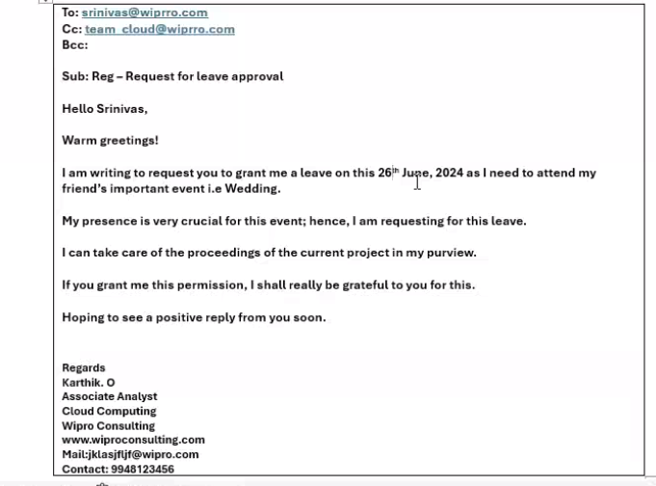

**Subject:** Urgent - Request for resending work assignment doc.

Hello Tom,

I hope you are well. While deleting junk mails, I accidentally deleted my work assignments which you shared with me post today’s meeting.

As you won’t be available for the next week, it would be really helpful if you resend the same to me so that I can continue my work for the next whole week.

I apologize for the inconvenience.

Thank you,

C

Data Analysts

Pro consulting

[www.proconsulting.com](http://www.proconsulting.com)

Mail : projashhd@pro.com

Contact : 41616346kb

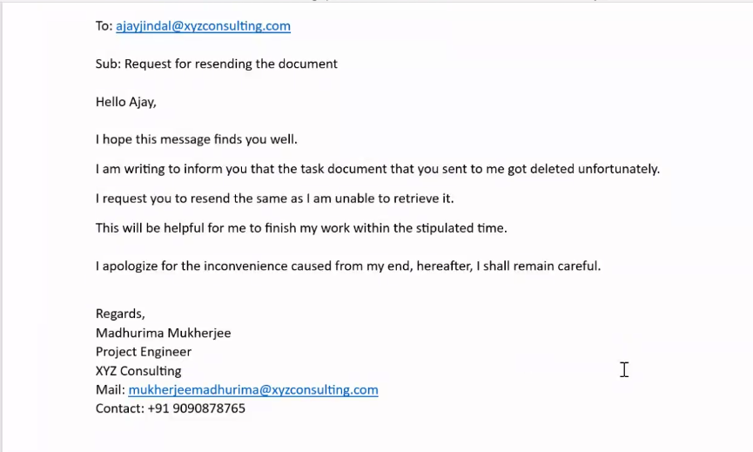

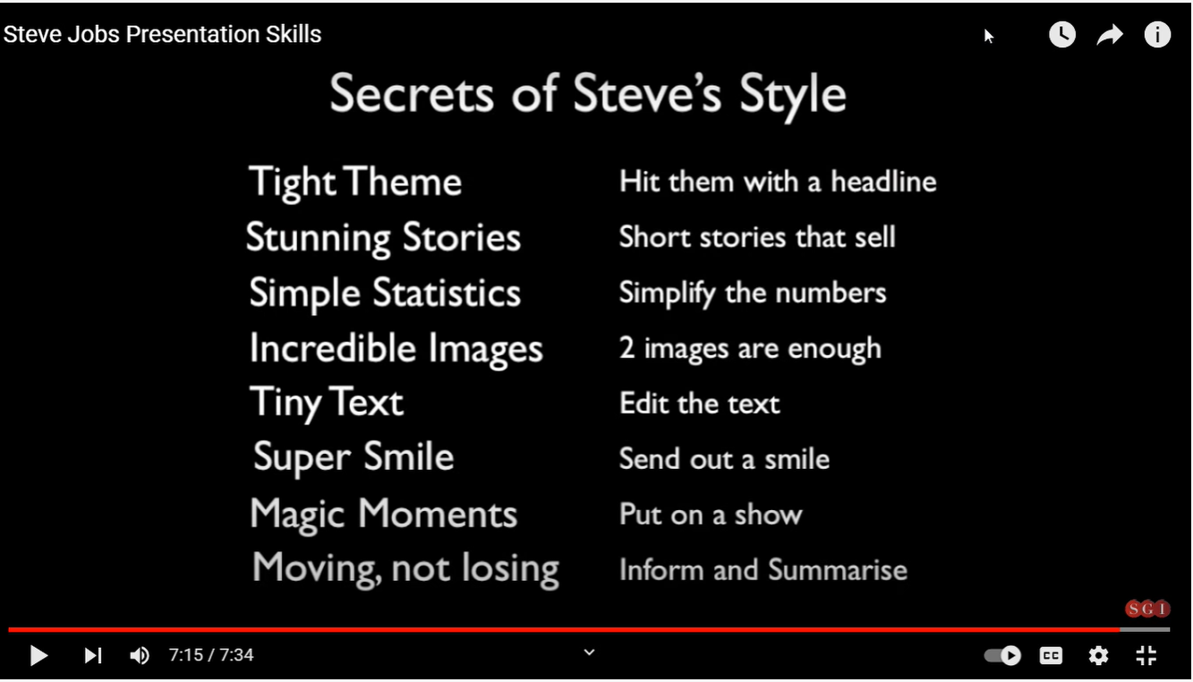

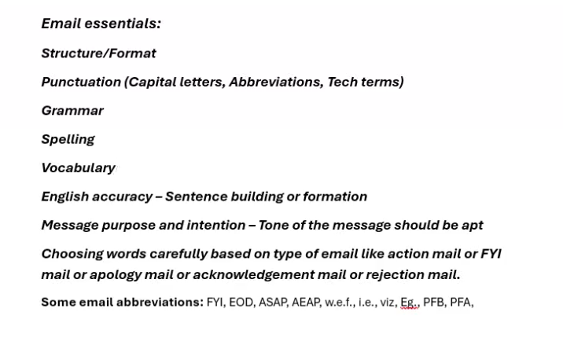

***Email requirements:***

1. **Recipients, CC, BCC**
2. **Subject – Related to the matter and understandable**
3. **Greeting/Salutation – Formal**
4. **Introductory line (s) - Regarding what?**
5. **Drawing attention or references to previous mails/conversations appropriately**
6. **Body of the message –  2-3 parts**
7. **Proper conjunctions for connecting para-to-para**
8. **Attachment (s) (folders/doc. names)**
9. **Closing lines/Subscription**
10. **Thanking**
11. **Attachments**
12. **Signature – Name, Designation, Contact, Website, Logo of the company**